[HOME](http://didmena.dvirtex.lt/index.php?route=common/home)[SEARCH](http://didmena.dvirtex.lt/index.php?route=product/search&search=42095)[UMIT CAMARO 2D 27,5" SIZE 18" (4...](http://didmena.dvirtex.lt/index.php?route=product/product&search=42095&product_id=10864)

CATEGORIES

* [LATEST](http://didmena.dvirtex.lt/index.php?route=product/latest)
* [!!! SALE !!!](http://didmena.dvirtex.lt/index.php?route=product/category&path=687)
* [WHEELS and PARTS](http://didmena.dvirtex.lt/index.php?route=product/category&path=351)
* [TOOLS and MAINTENANCE](http://didmena.dvirtex.lt/index.php?route=product/category&path=352)
* [PARTS](http://didmena.dvirtex.lt/index.php?route=product/category&path=347)
* [ACCESSORIES](http://didmena.dvirtex.lt/index.php?route=product/category&path=350)
* [BICYCLE CARRIERS](http://didmena.dvirtex.lt/index.php?route=product/category&path=478)
* [CLOTHING](http://didmena.dvirtex.lt/index.php?route=product/category&path=353)
* [TRAINERS AND ACCESSORIES](http://didmena.dvirtex.lt/index.php?route=product/category&path=415)
* [BICYCLES](http://didmena.dvirtex.lt/index.php?route=product/category&path=53)
* [SKATEBOARDS](http://didmena.dvirtex.lt/index.php?route=product/category&path=637)
* [THREE WHEEL](http://didmena.dvirtex.lt/index.php?route=product/category&path=649)
* [SCOOTERS](http://didmena.dvirtex.lt/index.php?route=product/category&path=631)

[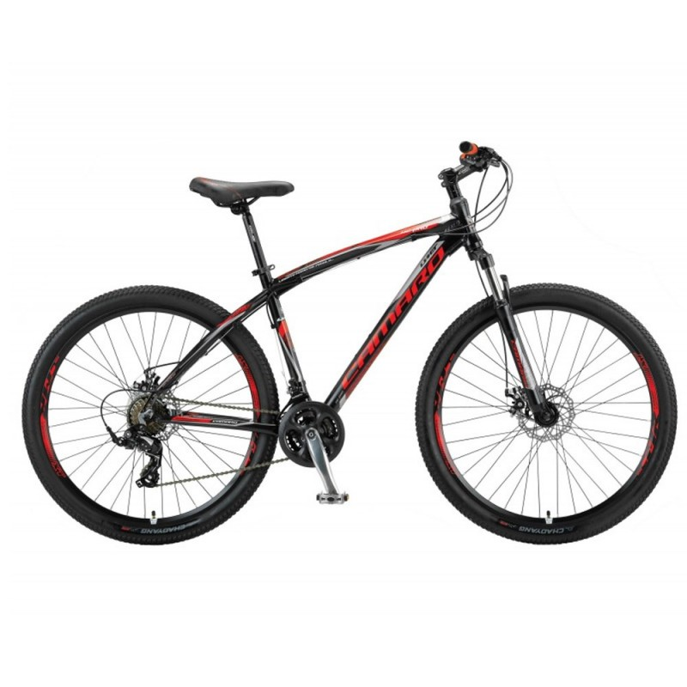](http://didmena.dvirtex.lt/image/cache/data/Dviraciai/UMIT/2018/mtb/camaro2draud-800x800.jpg)

**UMIT Camaro 2D 27,5" size 18" (46cm) (black/red/grey)**

197.52€

Qty:  

***Brand:***[*UMIT*](http://didmena.dvirtex.lt/index.php?route=product/manufacturer/info&manufacturer_id=27)***Product Code:***

*42095*

***Availability:****Out of Stock****Quantity in package:****0*

[SPECIFICATION](http://didmena.dvirtex.lt/#tab-attribute)[DESCRIPTION](http://didmena.dvirtex.lt/#tab-description)

| Main attributes | |
| --- | --- |
| Bike type | Mountain (MTB) |
| Wheel size | 27,5" |
| Frame size | 18" (46cm) |
| Frame | Aluminium |
| Gears | 21 |
| Weight | 15,2 kg |
| Color | Black |
| Fork & Handle Bar System | |
| Fork | Mode N780S |
| Brake System | |
| Brake type | Mechanical disc |
| Shifting-components | |
| Derailleur Front | Shimano Tourney TZ30 |
| Rear derailleur | Shimano Tourney TX55 |
| Rear shifter | Shimano Tourney EF51 |
| Shifter Front | Shimano Tourney EF51 |
| Drivetrain System | |
| Cassette-Sprocket | Shimano Tourney TZ21 |
| Chain | KMC Z33 |
| Crankset | Aluminium |
| Gear type | External |
| Wheelset | |
| Tires | Rubena Ocelot 27,5x2,10 |

[HOME](http://didmena.dvirtex.lt/index.php?route=common/home)[SEARCH](http://didmena.dvirtex.lt/index.php?route=product/search&search=42479)[UMIT CAMARO 2D H 27,5" SIZE 20" ...](http://didmena.dvirtex.lt/index.php?route=product/product&search=42479&product_id=8932)

CATEGORIES

* [LATEST](http://didmena.dvirtex.lt/index.php?route=product/latest)
* [!!! SALE !!!](http://didmena.dvirtex.lt/index.php?route=product/category&path=687)
* [WHEELS and PARTS](http://didmena.dvirtex.lt/index.php?route=product/category&path=351)
* [TOOLS and MAINTENANCE](http://didmena.dvirtex.lt/index.php?route=product/category&path=352)
* [PARTS](http://didmena.dvirtex.lt/index.php?route=product/category&path=347)
* [ACCESSORIES](http://didmena.dvirtex.lt/index.php?route=product/category&path=350)
* [BICYCLE CARRIERS](http://didmena.dvirtex.lt/index.php?route=product/category&path=478)
* [CLOTHING](http://didmena.dvirtex.lt/index.php?route=product/category&path=353)
* [TRAINERS AND ACCESSORIES](http://didmena.dvirtex.lt/index.php?route=product/category&path=415)
* [BICYCLES](http://didmena.dvirtex.lt/index.php?route=product/category&path=53)
* [SKATEBOARDS](http://didmena.dvirtex.lt/index.php?route=product/category&path=637)
* [THREE WHEEL](http://didmena.dvirtex.lt/index.php?route=product/category&path=649)
* [SCOOTERS](http://didmena.dvirtex.lt/index.php?route=product/category&path=631)

[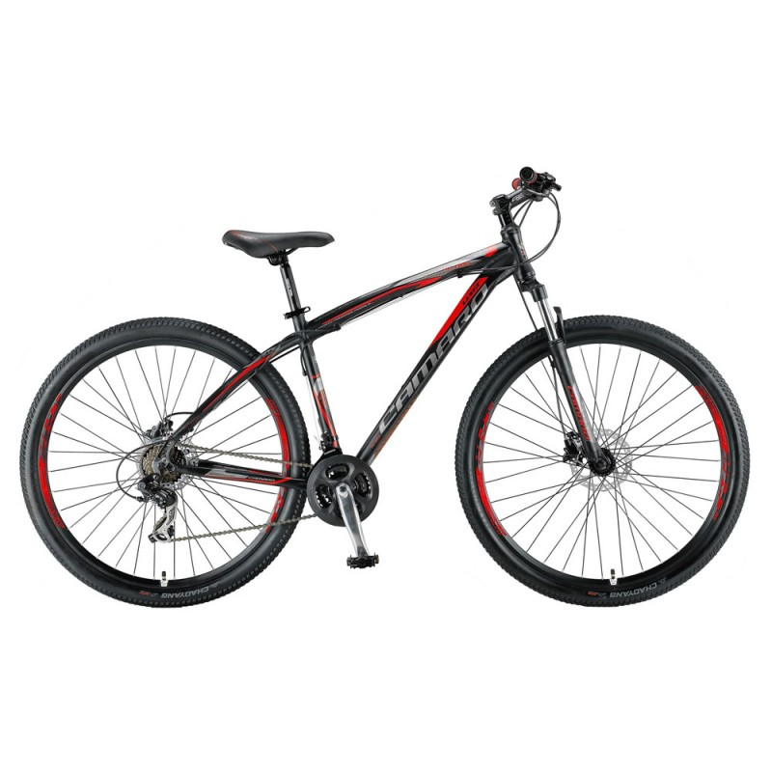](http://didmena.dvirtex.lt/image/cache/data/Dviraciai/UMIT/2017/mtb/camaro%202d%20h%20red-800x800.jpg)

**UMIT Camaro 2D H 27,5" size 20" (51cm) (black/red)**

222.31€

Qty:  

***Brand:***[*UMIT*](http://didmena.dvirtex.lt/index.php?route=product/manufacturer/info&manufacturer_id=27)***Product Code:***

*42479*

***Availability:****Out of Stock****Quantity in package:****0*

[SPECIFICATION](http://didmena.dvirtex.lt/#tab-attribute)[DESCRIPTION](http://didmena.dvirtex.lt/#tab-description)

| Main attributes | |
| --- | --- |
| Bike type | Mountain (MTB) |
| Wheel size | 27,5" |
| Frame size | 20" (51cm) |
| Frame | Aluminium |
| Gears | 21 |
| Year of manufacture | 2017 |
| Weight | 15 kg |
| Color | Black |
| Fork & Handle Bar System | |
| Fork | Mode N780S |
| Brake System | |
| Brake type | Hydraulic disc |
| Shifting-components | |
| Derailleur Front | Shimano Tourney TZ30 |
| Rear derailleur | Shimano Tourney TX35 |
| Rear shifter | Shimano Altus M310 |
| Shifter Front | Shimano Altus M310 |
| Drivetrain System | |
| Cassette-Sprocket | Shimano Tourney TZ21 |
| Chain | KMC Z33 |
| Crankset | Aluminium |
| Gear type | External |
| Wheelset | |
| Tires | Rubena Ocelot 27,5x2,10 |

[HOME](http://didmena.dvirtex.lt/index.php?route=common/home)[SEARCH](http://didmena.dvirtex.lt/index.php?route=product/search&search=42604)[UMIT CAMARO 2D H 29" SIZE 16" (4...](http://didmena.dvirtex.lt/index.php?route=product/product&search=42604&product_id=10843)

CATEGORIES

* [LATEST](http://didmena.dvirtex.lt/index.php?route=product/latest)
* [!!! SALE !!!](http://didmena.dvirtex.lt/index.php?route=product/category&path=687)
* [WHEELS and PARTS](http://didmena.dvirtex.lt/index.php?route=product/category&path=351)
* [TOOLS and MAINTENANCE](http://didmena.dvirtex.lt/index.php?route=product/category&path=352)
* [PARTS](http://didmena.dvirtex.lt/index.php?route=product/category&path=347)
* [ACCESSORIES](http://didmena.dvirtex.lt/index.php?route=product/category&path=350)
* [BICYCLE CARRIERS](http://didmena.dvirtex.lt/index.php?route=product/category&path=478)
* [CLOTHING](http://didmena.dvirtex.lt/index.php?route=product/category&path=353)
* [TRAINERS AND ACCESSORIES](http://didmena.dvirtex.lt/index.php?route=product/category&path=415)
* [BICYCLES](http://didmena.dvirtex.lt/index.php?route=product/category&path=53)
* [SKATEBOARDS](http://didmena.dvirtex.lt/index.php?route=product/category&path=637)
* [THREE WHEEL](http://didmena.dvirtex.lt/index.php?route=product/category&path=649)
* [SCOOTERS](http://didmena.dvirtex.lt/index.php?route=product/category&path=631)

[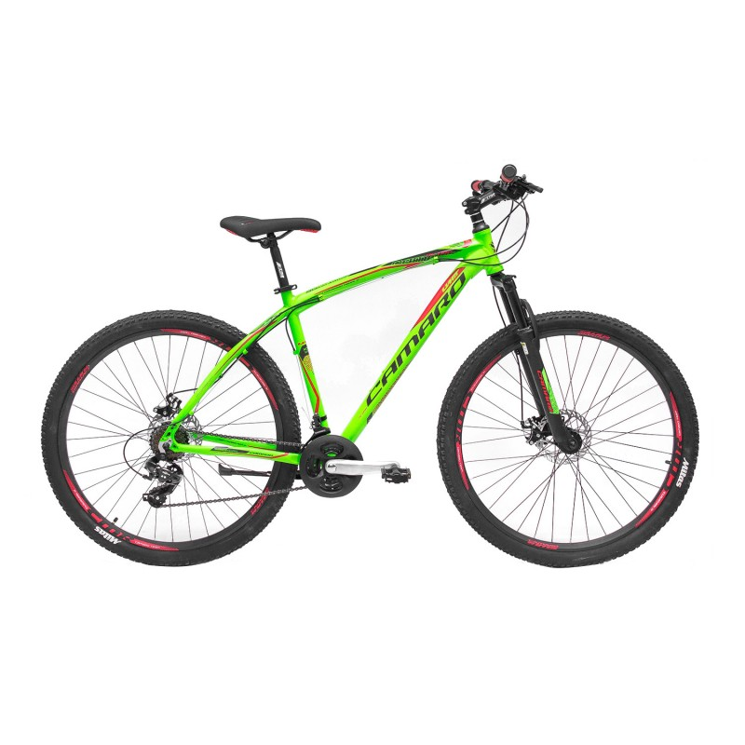](http://didmena.dvirtex.lt/image/cache/data/Dviraciai/UMIT/2018/mtb/42492-800x800.jpg)

**UMIT Camaro 2D H 29" size 16" (41cm) (green/black/red)**

238.84€

Qty:  

***Brand:***[*UMIT*](http://didmena.dvirtex.lt/index.php?route=product/manufacturer/info&manufacturer_id=27)***Product Code:***

*42604*

***Availability:****Out of Stock****Quantity in package:****0*

[SPECIFICATION](http://didmena.dvirtex.lt/#tab-attribute)[DESCRIPTION](http://didmena.dvirtex.lt/#tab-description)

| Main attributes | |
| --- | --- |
| Bike type | MTB |
| Wheel size | 29" |
| Frame size | 16" (41cm) |
| Frame | Aluminium |
| Gears | 21 |
| Weight | 15,6 kg |
| Color | Green |
| Fork & Handle Bar System | |
| Fork | CMR Suspension HT-982 |
| Fork lockout type | Manual |
| Brake System | |
| Brake type | Hydraulic disc |
| Brakes | Sparkle HDM300 |
| Shifting-components | |
| Derailleur Front | Shimano Tourney TZ30 |
| Rear derailleur | Shimano Tourney TY300 |
| Rear shifter | Shimano Altus M310 7x3 |
| Shifter Front | Shimano Altus M310 7x3 |
| Drivetrain System | |
| Cassette-Sprocket | Shimano Tourney TZ500 |
| Chain | KMC Z33 |
| Gear type | External |
| Wheelset | |
| Rims | Double aluminium |
| Tires | Rubena Ocelot 29x2.10 |